Publish a photo (from your files, on your computer) inside your text

Select with your mouse the position where you want to insert the image; inside the text of your blog entry.

- Click on the camera symbol above the Body field
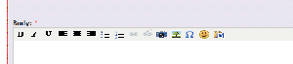
- Click on Upload image
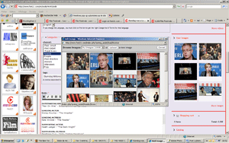
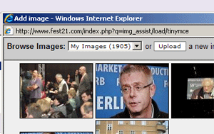

- Give it a title and click on browse to select the image from your files
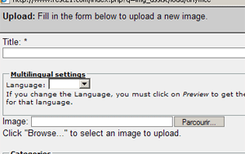
- In “Categories” Select an Image Galleries: festival poster or film poster or film still …or none if this is not relevant
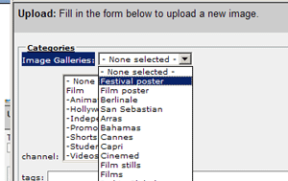
If you do so your picture will also be featured in the very popular section of the sites called Pix galleries available here

- Submit click ONCE (wait for the picture to upload a few seconds)
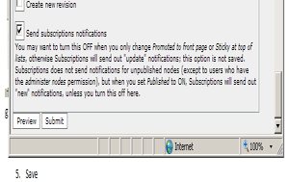
- You may choose to display the image inside your text as a small vignette or full size
Just select thumbnail or preview; click ONCE on INSERT (wait for the upload a few seconds, don’t click twice which would repeat the upload)
