

Filmfestivals.com & Fest21.com
Leading Pro media and social network for the film & festivals worldwide

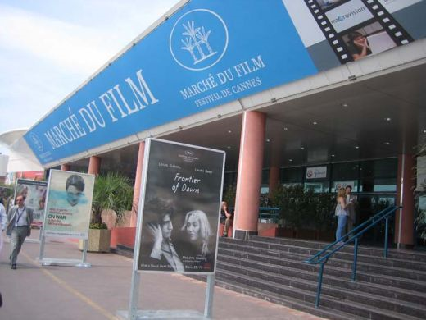

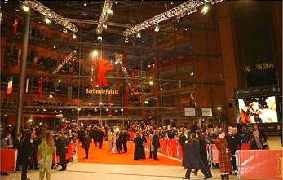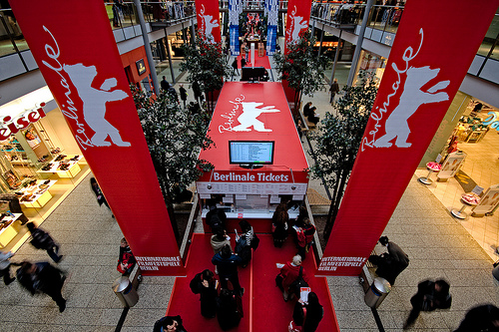

The growing number of film festivals
Filmfestivals.com was launched in 1995. The number of festivals has grown tremendously since then, almost doubling. The site developed into the premier exhaustive directory and professional portal, recognised as a trusted source of information in this changing environment.

The international reputation
Tribeca, Dubai, Rome… are striking examples of festivals quickly reaching the international league through a strong worldwide reputation as have done long before Toronto or Sundance.

A strong brand reputation (strong awareness, legitimacy, solid sponsorships, audience and media support and growing box office...) allows access to more and better films.

The search for films
Some festivals strictly focus on local/national filmmakers, others prefer to show to their audience film from as broad a source as possible, including new international filmmakers, new upcoming talent...Our audience is 45% US 55% rest of the world, our websites is the first website they check when they start focusing on the festival circuit.

Internet is becoming the leading media, the first tool for festivals and filmmakers…
The media is growing into the first strategic tool to communicate, promote, submit, call for film, review, showcase, organize, sell…
Congratulations!
Your festival has now an official blog on fest21.com: the first online social network for festivals and filmmakers worldwide (4000 festivals, and thousands of filmmakers attracted by the festival circuit).
Your blog’s url is worth mentioning along your other blogs or profiles in social networks since it is the only one in an environment strictly dedicated to film.
Please use the attached logo to link to our site and improve your google ranking by doing so.
The monthly traffic show over 350 000 unique visitors on our website: be sure to connect with them in the best way possible, with fully detailed data and high visibility.
A few tips to achieve optimal online presence:
Your Official Festival Blog
Make sure the name of your blog is spelt the exact (shortest) way you wish people to find you in the directory ie "Cannes Film Festival" rather than "cannesfilmfestival" or “Bahamas International Film Festival” instead of “BIFF”
Publish regularly in your blog, ask your publicists to post (create/create text) all your press releases (improve your google ranking), add festival poster as image, trailer as video entry, url of official site…
Blogs that are updated stand out hitting the “recently updated blogs” listing on the site’s homepage.

Publish the call for entry and select “call for entry” channel to be featured for free here:
http://www.fest21.com/en/channel/festivals/call_for_entry
and
http://www.filmfestivals.com/bulletin/index.shtml
We have paying services to promote more heavily with banners…and drive scores or hundreds of entries according to your budget.

PROMOTE the Festival on the web
Finally “the killer ap” use your personal RSS feed (it is specific to your blog and contains all your publications) copy the link below (XML) and enter in your other blogs profiles it will re publish automatically all your content on Facebook, MySpace or any blog you may have. No need to copy/paste one by one, use fest21 as the mother blog.
View my profileImagesVideos

Festival Directory Listing for your fest
Your blog is linked in our system to your festival entry.
The database is jointly featured on our sites filmfestivals.com and fest21.com.
All updates are done through fest21.com
If you do not have a festival listing yet: click create/register a festival once you are logged to your blog profile.
If you already have a festival listed click (top right) under festival information and select edit
To update the festival entry, fill as many details as you can, including genre, beginning and deadline of call for entry, price range of submission fee, links to the regulations, ticketing, upload the entry form as a file
Select accept submission from fest21.com if you want our international audience to submit in ONE click to your festival. To delete duplicate festival entries: click edit and select delete

FestivalExpress: Online Flm submission suite film
Try the new beta submission suite for filmmakers (who just need to register on fest21.com) and free for festivals Check online (check the attachment).

Filmfestivals.com Services
Filmfestivals.com proposes a large range of information, services, promotion and online tools, Most of them are free, the ones with higher impact are charged at nominal price:

Information
- Festival and Film Directories
We run the most comprehensive Festival Directory and the New Film Directory.
- News channels, newsfeeds
- Weekly Newsletter to 77 000 film pros.

Promotion
- Promotion
International promotion. Multifaceted Internet promotion packages…
- Viral Marketing optimizing your internet presence and ranking
(powered by our Business Units Film Festivals Buzz and Major Buzz Factory)

Services
- Bulletin Boards Designed to boost submissions from our international audience
- Online presence
Creation of the online space, the online community / social network geared towards the promotion of the event.
- Custom publishing, dailies…
- Online submission suite
FestivalExpress the online film submission tool with online back office for film producers and festival organizers.
- Private VOD
- Travel packages powered by our Business Unit “Film Festivals Travels”
- Conferences (Future of Cinema Salon in Cannes, Locarno…)
- Consulting (optimize your Cannes presence, festival sponsoring strategy...)

More details online on our promo services Check here.

Call for partnerships, promotion or editorial packages
Bruno Chatelin
bruno@filmfestivals.com
+33 1 72 74 71 79

Mao Girod de l’Ain
malo@filmfestivals.com
+33 1 72 74 71 78

